**PIZZA SALES SQL QUERIES**

-- Server: HIMANSHU

-- Full Table

select * from [dbo].[pizza_sales];

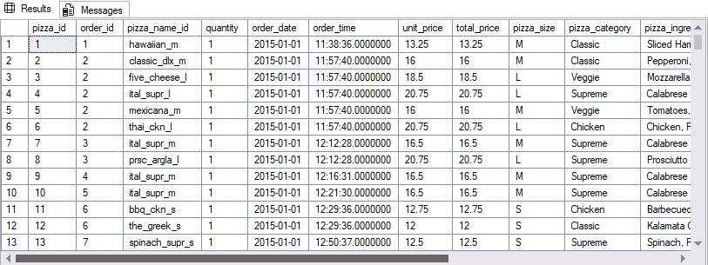

-- KPI's

-- Total Revenue

select sum(total_price) as Total_Revenue from pizza_sales;



-- Average order Value

select sum(total_price)/count(distinct order_id) as Avg_Order_Value from pizza_sales;



-- Total Pizza's Sold

select sum(quantity) as Total_Quantity from pizza_sales;



-- Total Orders

select count(distinct order_id) as Total_Orders from pizza_sales;



-- Average Pizzas Per Order

select cast(cast(sum(quantity) as decimal(10, 2)) /

cast(count(distinct order_id) as decimal(10,2)) as decimal(10, 2)) Avg_Pizza_Per_Order from pizza_sales;



-- Chart Requirements

-- Daily trends for total orders:

SELECT DATENAME(DW, order_date) AS order_dayy,

COUNT(DISTINCT order_id) AS Total_Orders_Per_Day

FROM pizza_sales

GROUP BY DATENAME(DW, order_date);

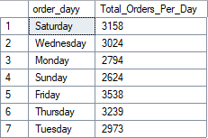

-- Hourly trend for total orders:

SELECT DATEPART (HOUR, order_time) as order_time,

COUNT(DISTINCT order_id) as Total_Irders_per_Hour

FROM pizza_sales

GROUP BY DATEPART(HOUR, order_time)

ORDER BY DATEPART(HOUR, order_time);

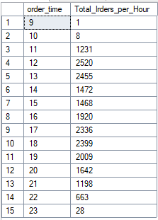

-- Percentage of sales by pizza category

SELECT pizza_category, sum(total_price) as Total_Sales, sum(total_price) * 100 /

(SELECT sum(total_price) from pizza_sales ) as PCT

FROM pizza_sales

group by pizza_category;

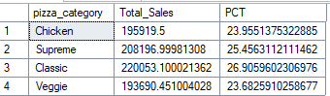

-- Percentage of sales by pizza category for first month

SELECT pizza_category, sum(total_price) as Total_Sales, sum(total_price) * 100 /

(SELECT sum(total_price) from pizza_sales WHERE MONTH(order_date) = 1) as PCT

FROM pizza_sales

WHERE MONTH(order_date) = 1

group by pizza_category;

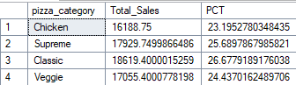

-- Percentage of sales by pizza size

SELECT pizza_size, cast(sum(total_price) as DECIMAL (10, 2)) Total_Sales, cast(sum(total_price) * 100 /

(SELECT sum(total_price) from pizza_sales ) as DECIMAL (10, 2)) as PCT

FROM pizza_sales

group by pizza_size

ORDER BY PCT DESC;

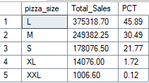

-- Percentage of sales by pizza size for the first quarter

SELECT pizza_size, cast(sum(total_price) as DECIMAL (10, 2)) Total_Sales, cast(sum(total_price) * 100 /

(SELECT sum(total_price) from pizza_sales WHERE DATEPART(QUARTER, order_date) = 1 ) as DECIMAL (10, 2)) as PCT

FROM pizza_sales

WHERE DATEPART(QUARTER, order_date) = 1

group by pizza_size

ORDER BY PCT DESC;

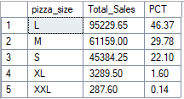

-- Total Pizza Sales by Pizza Category

SELECT pizza_category, cast(sum(quantity) as DECIMAL (10, 2)) Total_Quantity

FROM pizza_sales

group by pizza_category;

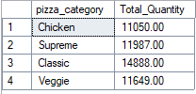

-- Top 5 best sellers by total pizza's sold

SELECT TOP 5 pizza_name, cast(sum(quantity) as DECIMAL(10, 2)) Total_quantity

FROM pizza_sales

GROUP BY pizza_name

ORDER BY Total_quantity DESC;

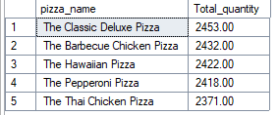

-- Top 5 best sellers by total pizza's sold for January

SELECT TOP 5 pizza_name, cast(sum(quantity) as DECIMAL(10, 2)) Total_quantity

FROM pizza_sales

WHERE MONTH(order_date) = 1

GROUP BY pizza_name

ORDER BY Total_quantity DESC;

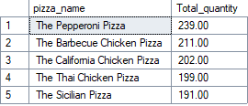

-- Bottom 5 best sellers by total pizza's sold

SELECT TOP 5 pizza_name, cast(sum(quantity) as DECIMAL(10, 2)) Total_quantity

FROM pizza_sales

GROUP BY pizza_name

ORDER BY Total_quantity;

